# QUESTION PAPER -5

QUANT QUESTIONS

1. A boat moves downs the stream at the rate of 1 km in 10 minutes and upstream at the rate of 4 km an hour. What is the velocity of the current?
2. 1.5 km/hr.
3. 2 km/hr.
4. 1 km/hr.
5. 2.5 km/hr.
6. A man is 18 years older than his son. In 5 years, his age will be thrice the age of his son. The present age of the son is
7. 3 years
8. 4 years
9. 5years
10. 6years
11. Anita had to do a multiplication. Instead of taking 35 as one of the multipliers, she took 53. As a result, the product went up by 540. What is the new product?
12. 1050
13. 540
14. 1440
15. 1590
16. Martina bought a machine for Rs 75,000 and spent Rs 5000 on repair and Rs 1000 on transport. And sold it with 25% profit. At what price did she sell the machine?
17. 109000
18. 110000
19. 109350
20. 110350
21. Four dice are rolled simultaneously. What is the number of possible outcomes in which at least one of the die shows 6?
22. 6! / 4!
23. 625
24. 671
25. 1296
26. The average of 5 consecutive integers starting with m as the first integer is n. What is the average of 9 consecutive integers that start with m+2?

1. m + 4
2. n + 6
3. n + 3
4. m + 5
5. n + 4
6. 60 litres of diesel is required to travel 600 km using a 800 cc engine. If the volume of diesel required to cover a distance varies directly as the capacity of the engine, then how many litres of diesel is required to travel 800 kms using 1200 cc engine?   
   A. 80 litres

B. 90 litres

C. 120 litres

D. 170 litres

1. A sum of Rs 15000 deposited at compound interest becomes double after 5 years . After 20 years , it will become :
2. Rs 200000
3. Rs 240000
4. Rs 250000
5. Rs 192000

**Direction : Each of the questions given below consists of a question followed by three statements. You have to study the question and the statements and decide which of the following statement(s) is/are necessary to answer the question**

1. What is the speed of the train ?
2. The train crosses a tree in 13 seconds.
3. The train crosses a platform of length 250 meters in 27 seconds.
4. The train crosses another train running in the same direction in 32 seconds
5. I and II only
6. II and III only
7. I and III only
8. Any two of the three
9. None of these
10. Twenty two Australians and 16 Russians can complete a piece of work in 10 days, whereas 22 British and 6 Russians can complete the same work in 12 days. In how many days will one Australian, working along with one Russian and 1 British can complete the work?
11. 120 days
12. 40 days
13. 60 days
14. 30 days
15. Steve can travel up the stream at 10 kmph and down the stream at 20 kmph. Find the man rate in still water and also find the rate of the stream.
16. 15,10
17. 16,6
18. 15,5
19. 14,6

**LOGICAL QUESTIONS**

Choose the correct answer that logically follow the main statement.

1. I am suffering either from fever or headache.
   1. i am not suffering from headache.
   2. I am suffering from fever.
   3. I am not suffering from malaria.
   4. none of these.

DATA SUFFICIENCY

1. How many fans watched the football match yesterday?
2. Each pass admits utmost 3 people.
3. Totally, 1500 passes were sold.

|  |
| --- |
| 1. I alone is sufficient while II alone is not sufficient. |
| 1. II alone is sufficient while I alone is not sufficient. |
| 1. Either I or II is sufficient. |
| 1. Neither I nor II is sufficient. |
| 1. Both I and II are sufficient. |

SERIES COMPLETION :

1. D4  H8 L12 ?

a. P18

b. O16

c. O18

d. P16

**Q4: In each of these questions, two statements are followed by two conclusions A and B. Assume the given statements to be true, even if they are at variance with commonly known facts. Choose the correct alternative from among A, B, C and D given below:**

Statements:

All aeroplanes are trains.

Some trains are chairs.

Conclusions:

* 1. Some aeroplanes are chairs.
  2. Some chairs are aeroplanes.
  3. Some chairs are trains.
  4. Some trains are aeroplanes.

A. None follows

B. Only I and II follow

C. Only II and III follow

D. Only III and IV follow

ANALOGY

1. Labyrinth : complicated : : __________ : _________

a. Tempo : upbeat

b. Enigma : mysterious

c. Narrator : biased

d. Legend : credible

**VERBAL**

Give the synonym of the give word below

1. Terrible
2. Sweet
3. Incredible
4. Strange
5. Horrible

SENTENCE CORRECTION

1. At the end of one year Catherine presented her husband with a living token of their mutual love, and that circumstance increased their _____felicity.
2. Conjugal
3. Parochial
4. Incipient
5. Nuptial
6. Repine

PARA JUMBLE

1. The major threat to humanity comes from the development of nuclear sciences.
2. Furthermore, there is an ever increasing demand of petrol and diesel for running various means of transport.
3. As a result, a heavy amount of carbon monoxide, hydrocarbon, sulphur-dioxide and many more gases are polluting the air.
4. Many industries have come up owing to rapid urbanization.
   * + - 1. 4123
         2. 4231
         3. 1324
         4. 1423

In the following questions choose the word which is the exact OPPOSITE of the given words.

1. BENEVOLENT
2. Benign
3. Caring
4. Humane
5. Selfish
6. BARREN
7. Desert
8. Depleted
9. Fertile
10. Arid

**DATA INTERPRETATION**

**Directions for questions 21 to 24**

**Answer the questions on the basis of the information given below. The data points in the figure below represent monthly income and expenditure data of individual members of the AJAY family ( ■), the BOB family (□), the CHARLIE family (○), and the DEV family (●). For these questions, savings is defined as**

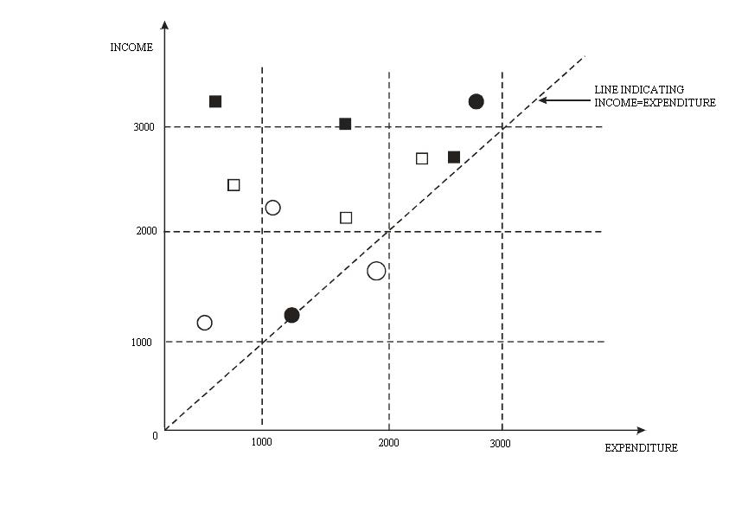

1. **Which family has the lowest average income?**  
   A. AJAY  B. BOB  C. CHARLIE D. DEV
2. **Which family has the highest average expenditure?**  
   A. AJAY  B. BOB  C. CHARLIE D. DEV
3. **Which family has the lowest average savings?**  
   A. AJAY  B. BOB  C. CHARLIE D. DEV
4. **The highest amount of savings accrues to a member of which family?**  
   A. AJAY  B. BOB  C. CHARLIE D. DEV

**Directions for questions Q25 to Q29:**

**Answer the questions on the basis of the information given below .Prof. Sunil has been tracking the number of visitors to his homepage? His service provider has provided him with the following data on the country of origin of the visitors and the university they belong to:**Number of visitors:

|  |  |  |  |
| --- | --- | --- | --- |
|  | DAY | | |
| COUNTRY | 1 | 2 | 3 |
| China | 2 | 0 | 0 |
| UAE | 1 | 1 | 0 |
| India | 1 | 2 | 0 |
| UK | 2 | 0 | 2 |
| USA | 1 | 0 | 1 |

Number of visitors:

|  |  |  |  |
| --- | --- | --- | --- |
|  | DAY | | |
| UNIVERSITY | 1 | 2 | 3 |
| University 1 | 1 | 0 | 0 |
| University 2 | 2 | 0 | 0 |
| University 3 | 0 | 1 | 0 |
| University 4 | 0 | 0 | 2 |
| University 5 | 1 | 0 | 0 |
| University 6 | 1 | 0 | 1 |
| University 7 | 2 | 0 | 0 |
| University 8 | 0 | 2 | 0 |

1. **To which country does University 5 belong?**

A. India or UAE but not USA  B. India or USA but not UAE

C. UAE or USA but not India  D. India or USA but not UK

1. **University 1 can belong to**  
   A. UK  B. China C. UAE  D. USA
2. **Which among the listed countries can possibly host three of the eight listed universities?**  
   A. None  B. Only UK

C. Only India  D. Both India and UK

1. **Visitors from how many universities from UK visited Prof. Sunil’s homepage in the three days?**  
   A. 1  B. 2  C. 3  D. 4
2. Mathew started a business with Rs.20,000. John joined him after 4 months with Rs.30,000. After 2 months, Mathew withdrew Rs.5,000 of his capital and 2 more months later, John brought in Rs.20,000 more. What should be the ratio in which they should share their profits at the end of the year?
3. 20:30
4. 21:31
5. **21:32**
6. 22:31
7. Find the value of x in Log3 (Log4 (log2 x)) = 1

A) 810 B) 1024 C) 4.96 D) 4096

Ans) D

1. In a certain code, ‘PLANT’ is written as $@2*c and Yield is written as b64@!. What is the code for Delay?
2. b4*2!
3. b4@2!
4. !42@b
5. **!4@2b**
6. **One of the two buses completes a journey of 300kms in 6hrs and the other a journey of 600kms in 8hrs. The ratio of their speeds is:**

**a)3:4**

**b) 2:3**

**c)3:2**

**d)2:4**

1. Anupam said to a lady sitting in a car, "The only daughter of the brother of my wife is the sister-in-law of the brother of your sister." How the husband of the lady is related to Anupam?

A. Maternal uncle B. Uncle

C. Father **D. Son-in-law**

1. A regular hexagon is inscribed in a circle of radius r cm. What is the perimeter of the regular hexagon?
   1. 3r
   2. **6r**
   3. 27r
   4. 9r
2. A number is selected at random from first thirty natural numbers. What is the chance that it is a multiple of either 3 or 13?
3. 17/30.
4. **2/5.**
5. 11/30
6. 4/15.
7. Three Vice Presidents (VP) regularly visit the plant on different days. Due to labour unrest, VP (HR) regularly visits the plant after a gap of 2 days. VP (Operations) regularly visits the plant after a gap of 3 days. VP (sales) regularly visits the plant after a gap of 5 days. The VPs do not deviate from their individual schedules. CEO of the company meets the VPs when all the three VPs come to the plant together. CEO is on leave from January 5th to January 28th, 2012. Last time CEO met the VPs on January 3, 2012. When is the next time CEO will meet all the VPs?
8. February 6, 2012
9. February 7, 2012
10. **February 8, 2012**
11. February 9, 2012
12. Maria had to do a multiplication. Instead of taking 35 as one of the multipliers, she took 53. As a result, the product went up by 540. What is the new product?
13. 1050
14. 540
15. 1440
16. **1590**
17. What is the highest power of 7 that can divide 5000! without leaving a remainder? (5000! means factorial 5000)
18. 4998
19. 714
20. **832**
21. 816
22. Pipe A usually fills a tank in 2 hours. On account of a leak at the bottom of the tank, it takes pipe A 30 more minutes to fill the tank. How long will the leak take to empty a full tank if pipe A is shut?
23. 2 hours 30 minutes
24. 5 hours.
25. **10 hours.**
26. 4hours.
27. In a kilometer race, X can give Z a start of 100 m or 15 seconds. How long does X take to complete the race?
28. 150 seconds
29. 165 seconds
30. **135 seconds**
31. 66.67 seconds